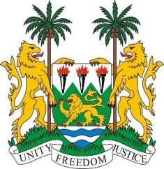
SIERRA LEONE
23rd Session of the UPR

LEBANON

2 November 2015

Mr President,

Sierra Leone welcomes the delegation of Lebanon and thanks them for the presentation of their national report.

My delegation notes with appreciation the concrete steps to further promote and protect human rights, including the adoption into national laws the accepted UPR recommendations; including implementing various laws and strategies to ensure the respect of the human rights of persons with disabilities, and the promotion of gender parity through the National Strategy for Women.

My delegation commends Lebanon for opening its doors to approximately 1.2 million refugees, but will however encourage Lebanon to pay greater attention to the human rights of all migrants, including domestic workers.

Recommendations:

- Ratify the ICRMW and accede to the ICPPED and CRPD.
- Establish an independent national human rights institution in conformity with the Paris Principles.
- Establish a moratorium with a view to abolishing the death penalty.
- Develop a strategy to combat child labour.
- Adopt laws to increase the age of criminal responsibility and to eliminate child early and forced marriage.

Sierra Leone would also encourage the government to withdraw its reservation to the various articles of the CEDAW and to modify its Citizenship Law to enable women to pass their nationality on to their children and spouses.

Sierra Leone wishes Lebanon every success.

Thank you, Mr President.

